**PROJECT REPORT**

ON

**ELECTRIC VEHICLE COMMUNICATION SYSTEM**

**Table of Content**

Aim

Abstraction

Objective

Key Differences by use Cases in Ev’s

**The Main Aim of the Project**

Design and develop an efficient communication system for electric vehicles (EVs) using CAN, LIN, and FlexRay protocols.

**The Objective of the Project**

To implement a robust communication system for electric vehicles (EVs) by integrating CAN, LIN, and FlexRay protocols, ensuring real-time, reliable communication between electronic control units (ECUs) for improved performance, safety, and system efficiency.

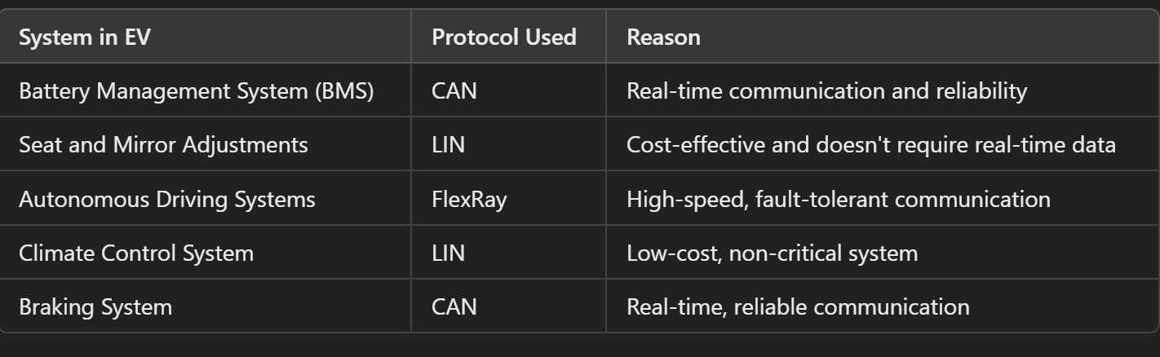

**What I Observe in Phase 1 and my report is here?**

1. **Understanding Protocols:** The report clearly explains what communication protocols are and why they're important for making sure the different electronic parts of EVs can talk to each other effectively.
2. **Types of Protocols:** It categorizes the various types of protocols used in EVs, such as those for communication, charging, and data transfer. It highlights the roles of protocols like CAN, LIN, V2V/V2I, and various charging standards, showing how diverse the communication needs are within EV systems.
3. **CAN Protocol:** The report dives deep into the CAN protocol, showcasing its strong and efficient real-time data transmission for critical vehicle systems. It explains how CAN handles error detection and its different operational modes.
4. **LIN Protocol:** LIN is described as a budget-friendly, slower alternative for less critical applications. The report illustrates its master-slave architecture, communication frames, and error handling, making it suitable for simpler vehicle functions.
5. **FlexRay Protocol:** FlexRay stands out for its high-speed and fault-tolerant design, perfect for modern EVs with strict communication needs. The report discusses its dual-channel architecture, time-triggered communication, and safety benefits.
6. **Comparative Analysis:** The report systematically compares CAN, LIN, and FlexRay, covering their data rates, costs, complexity, and use cases. This helps in understanding which protocol to use in different scenarios.
7. **Future Prospects and Upgrades:** The report wraps up by predicting future improvements in these protocols, which will enhance their capabilities and support upcoming automotive technologies.

**Overall Phase1 Report:**

The report offers a thorough and detailed understanding of these key communication protocols, their features, benefits, and future potential. It's a valuable resource for engineers and designers working in the EV industry.

**Phase 2 Report Observations:**

**Key Hardware Systems in EVs:**

* **Battery Pack** - Stores electrical energy, often using lithium-ion batteries.
* **Electric Motor** - Converts electrical energy into mechanical energy to drive the wheels.
* **Power Electronics Controller** - Manages energy flow from the battery to the motor, controlling speed and torque.
* **Onboard Charger** - Converts AC power from the grid to DC power for charging the battery.
* **Battery Management System (BMS)** - Monitors and manages the battery pack to ensure efficiency and safety.
* **Thermal Management System** - Maintains optimal temperature for various components.
* **Transmission** - Transfers power from the motor to the wheels.
* **Vehicle Control Unit (VCU)** - Acts as the brain, coordinating all electronic systems.

**ECUs (Electronic Control Units) in EVs:**

* **Engine Control Module (ECM)**
* **Transmission Control Module (TCM)**
* **Brake Control Module (BCM)**
* **Body Control Module (BCM)**
* **Suspension Control Module (SCM)**
* **Infotainment Control Module (ICM)**
* **Telematics Control Unit (TCU)**

**Sensors in EVs:**

* **Battery Management Sensors** for voltage, current, and temperature.
* **Speed and Position Sensors** for motor control.
* **Proximity and Radar Sensors** for safety and driver assistance.
* **Temperature and Humidity Sensors** for climate control.

**Actuators in EVs:**

* **Electric Motors** (for propulsion and auxiliaries)
* **Hydraulic/Pneumatic Actuators** (less common but used in specific systems)

**System Architecture and Network Topology:**

* Integrates various components like **BMS, motor control units, thermal management, and safety systems.**
* **Network Topology** determines how these components are connected, ensuring reliable communication across the vehicle's network.

**Phase 3 Report Observations:**